 Mumbai University
TPCT’s, TERNA ENGINEERING COLLEGE (TEC), NAVI MUMBAI

UG PROGRAM IN COMPUTER ENGINEERING

SUBMISSION REPORT FH 2021

Subject: Software Engineering (SE)
Class: TE (B)
Name of student: AMEY THAKUR
College ID: TU3F1819127
Roll No: 50
INDEX

Sr.No | Particulars | Submitted/Not Submitted or Enter Marks received
Experiments
1 | Prepare a detailed problem statement for the selected mini project and identify a suitable process model for the same with justification. | 9/10
2 | To prepare software Requirement Specification document(in IEEE format) for the selected mini-project. | 9/10
3 | Draw DFD (up to 2 levels) and prepare Data Dictionary for the project. | 9/10
4 | Identify scenarios & develop a UML Use case for the selected mini-project. | 9/10
5 | Develop a UML Class Diagram for the selected mini-project. | 9/10
6 | Develop Sequence and Collaboration diagram for the selected mini-project. | 9/10
7 | Develop Activity / State Transition diagram for the selected mini-project. | 9/10
8 | Study the project management tool and schedule project plan using any tool (Gantt Chart, Critical Path Method, and Earn Value Analysis). | 9/10
9 | Estimation of project metrics using COCOMO. | 10/10
10 | Design User Interface for the selected mini-project. | 9/10
11 | To prepare RMMM Plan for the selected mini-project. | 9/10
12 | Perform white box and black box testing and Develop test cases for same. | 9/10
Assignments
13 | Assignment No 1 | 9/10
14 | Assignment No 2 | 10/10
15 | Assignment No 3 | 9/10
Quizzes
16 | SE Quiz 1_Chapter 1 | 10/10
17 | SE Quiz 1_Chapter 2 | 10/10
18 | SE Quiz 1_Chapter 3 | 10/10
19 | SE Quiz 1_Chapter 4 | 10/10
20 | SE Quiz 1_Chapter 5 | 10/10
21 | SE Quiz 1_Chapter 6 | 10/10
IAT
22 | IAT-1 | 19/20
23 | IAT-2 | Submitted
Exit Survey
24 | Course Exit Survey | Submitted
25 | Laboratory Exit Survey | Submitted

Signature: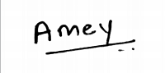

Experiments

Software Engineering Experiment 1
Marks: (9/10)
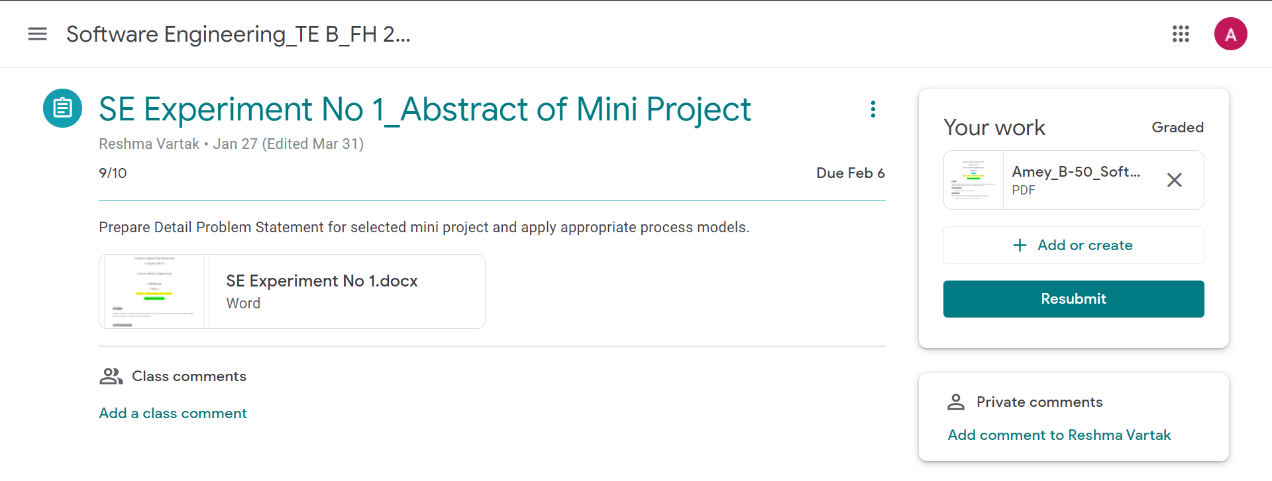
Software Engineering Experiment 2
Marks: (9/10)
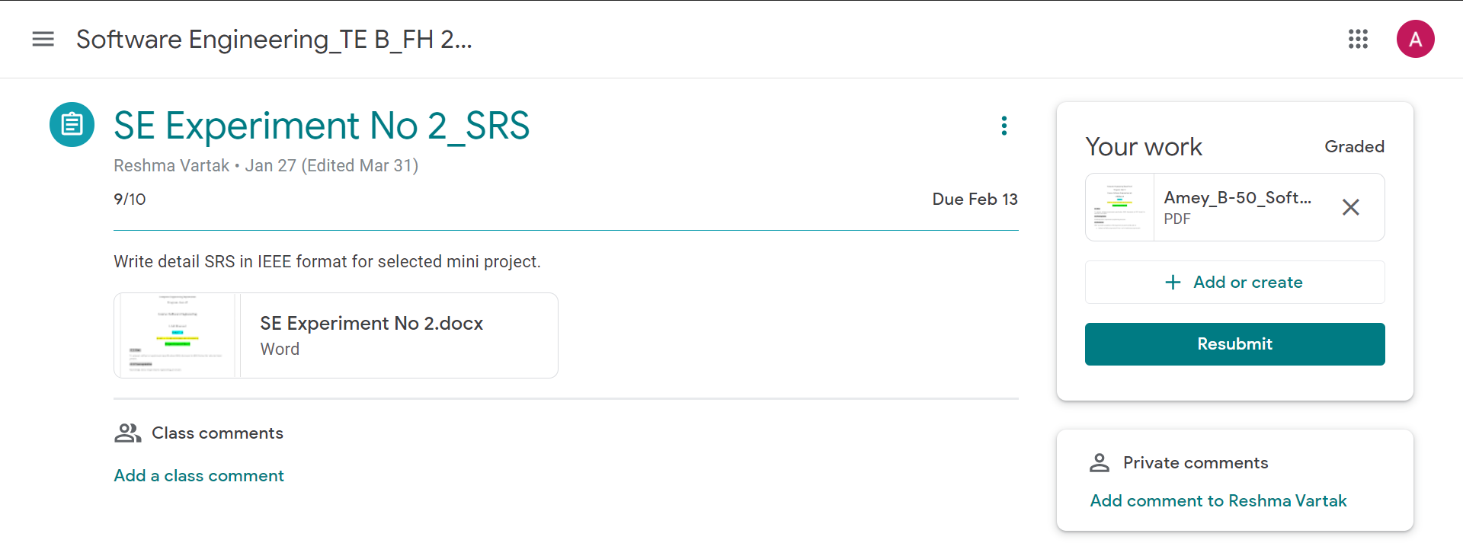
Software Engineering Experiment 3
Marks: (9/10)
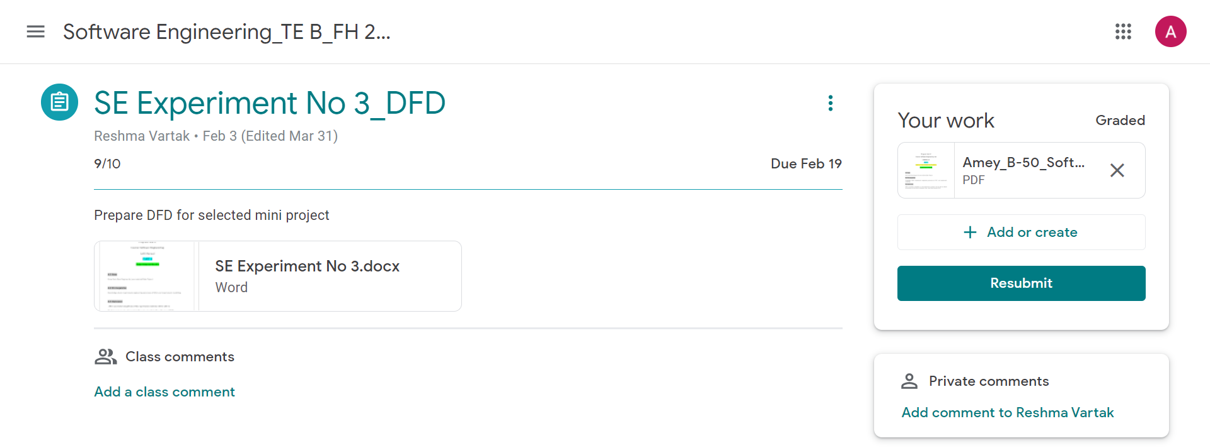

Software Engineering Experiment 4
Marks: (9/10)
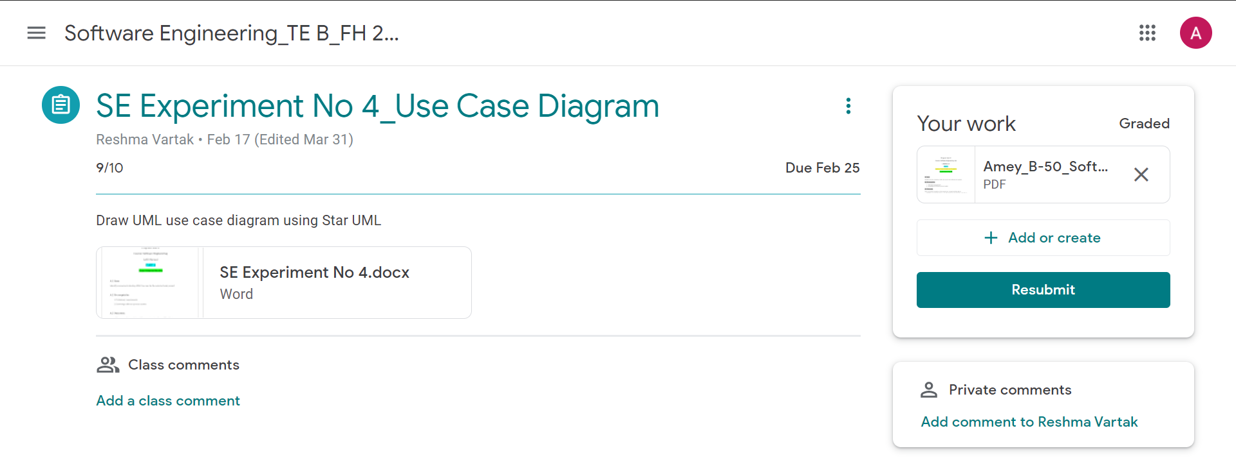

Software Engineering Experiment 5
Marks: (9/10)
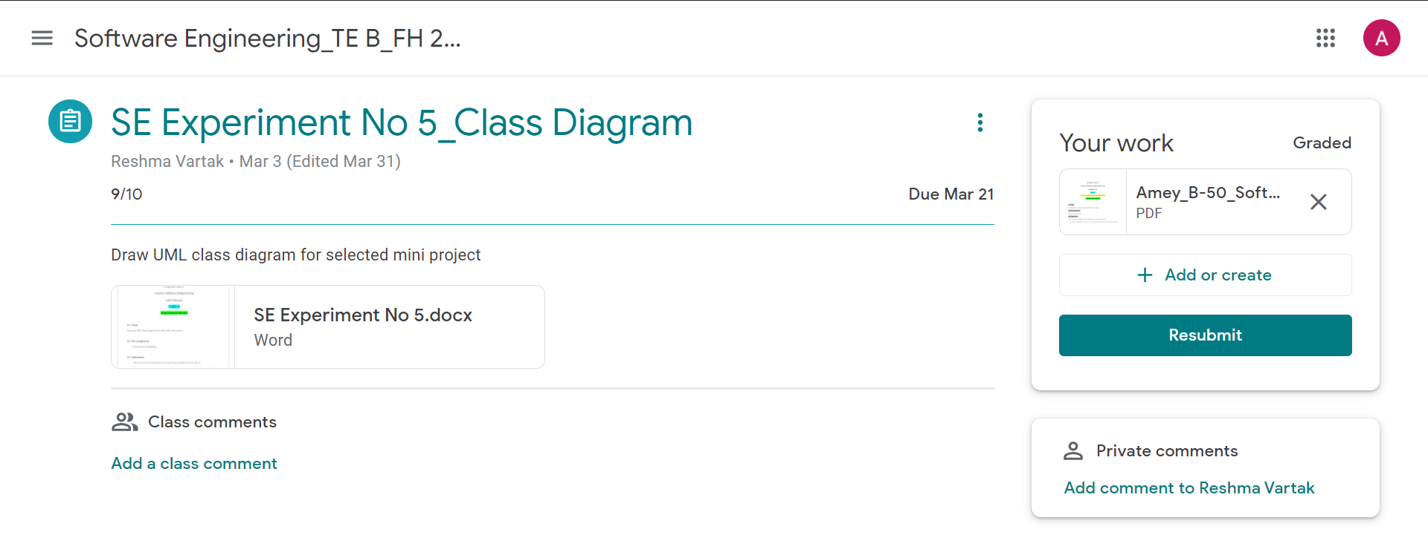

Software Engineering Experiment 6
Marks: (9/10)
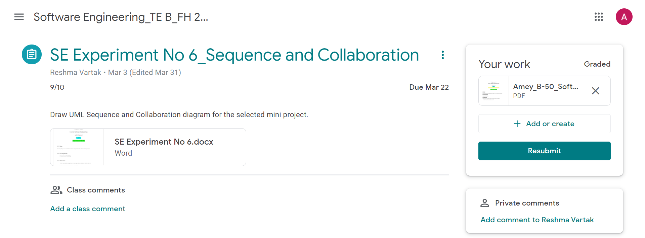

Software Engineering Experiment 7
Marks: (9/10)
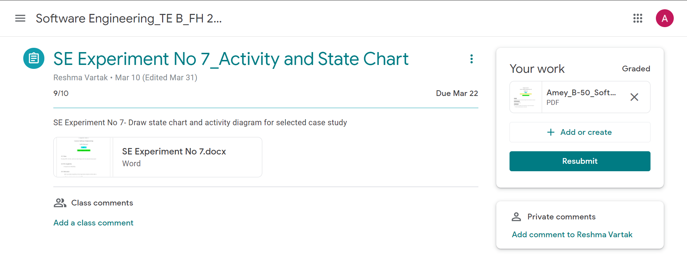

Software Engineering Experiment 8
Marks: (9/10)
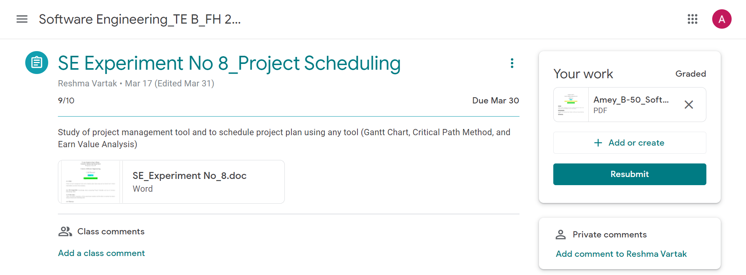

Software Engineering Experiment 9
Marks: (10/10)
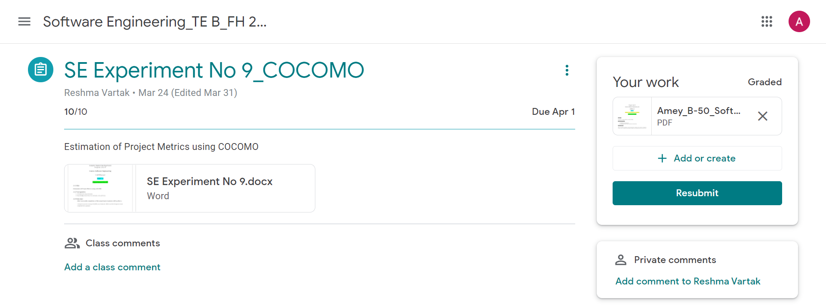

Software Engineering Experiment 10
Marks: (9/10)
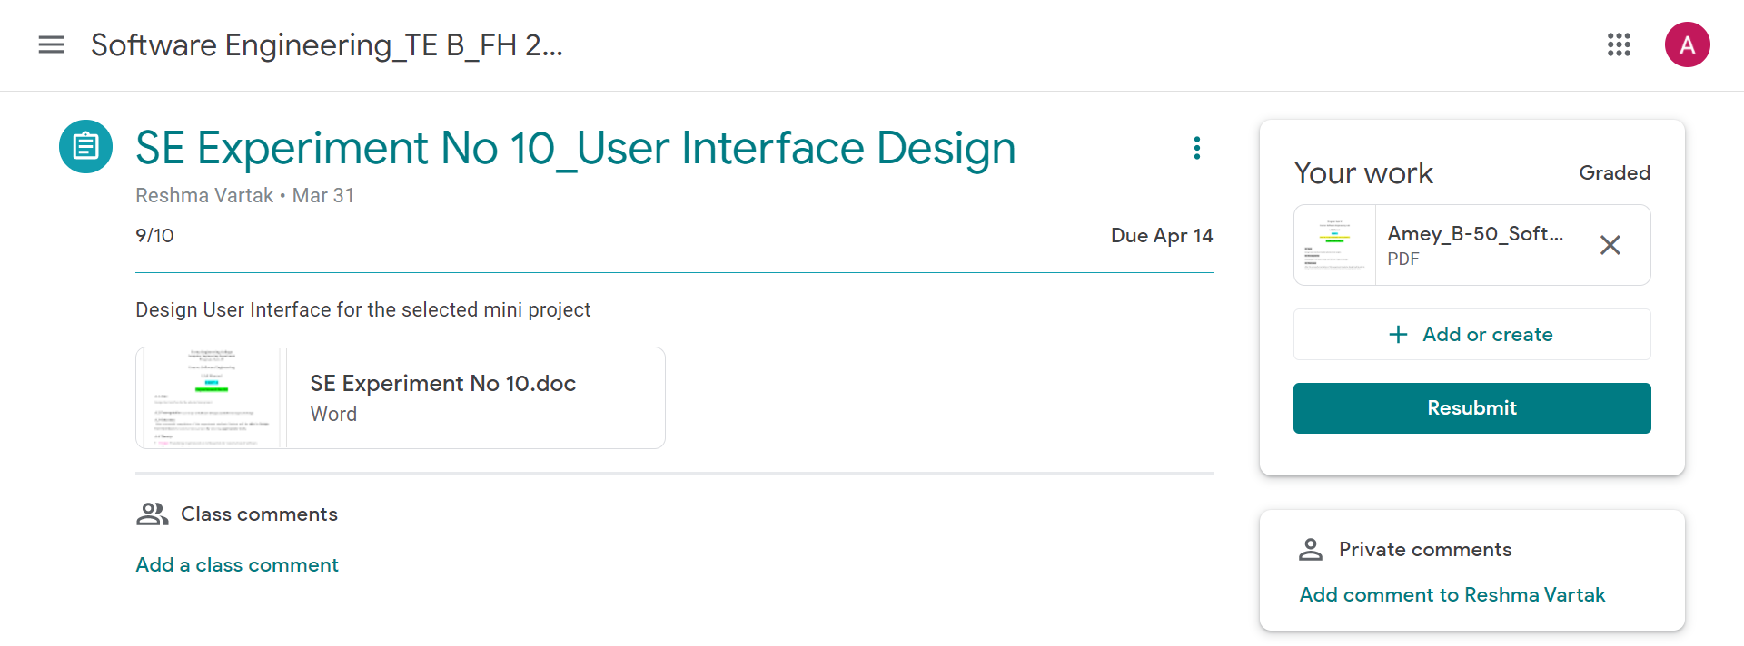

Software Engineering Experiment 11
Marks: (9/10)
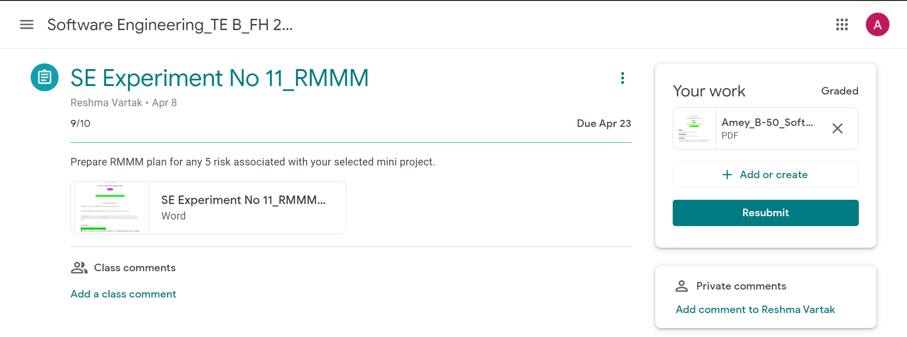

Software Engineering Experiment 12
Marks: (9/10)
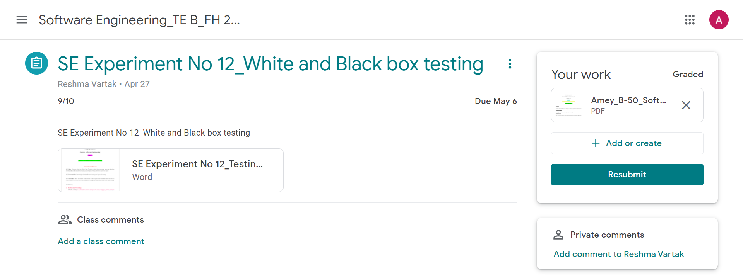

Assignments

Software Engineering Assignment 1
Marks: (9/10)
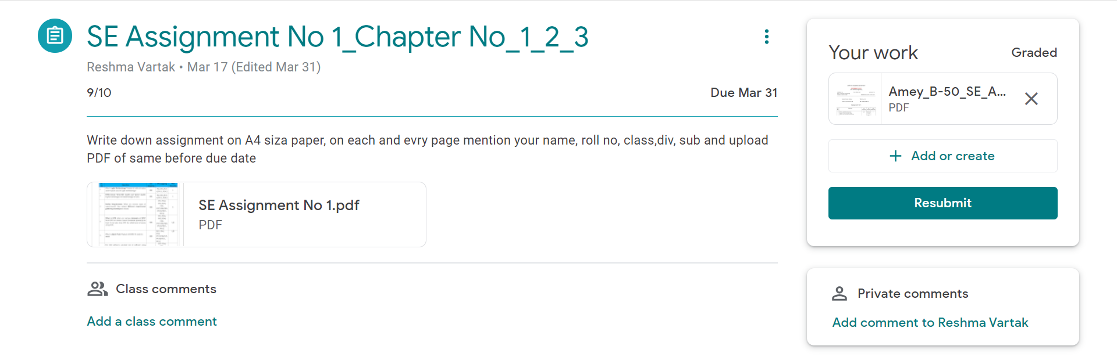
Software Engineering Assignment 2
Marks: (10/10)
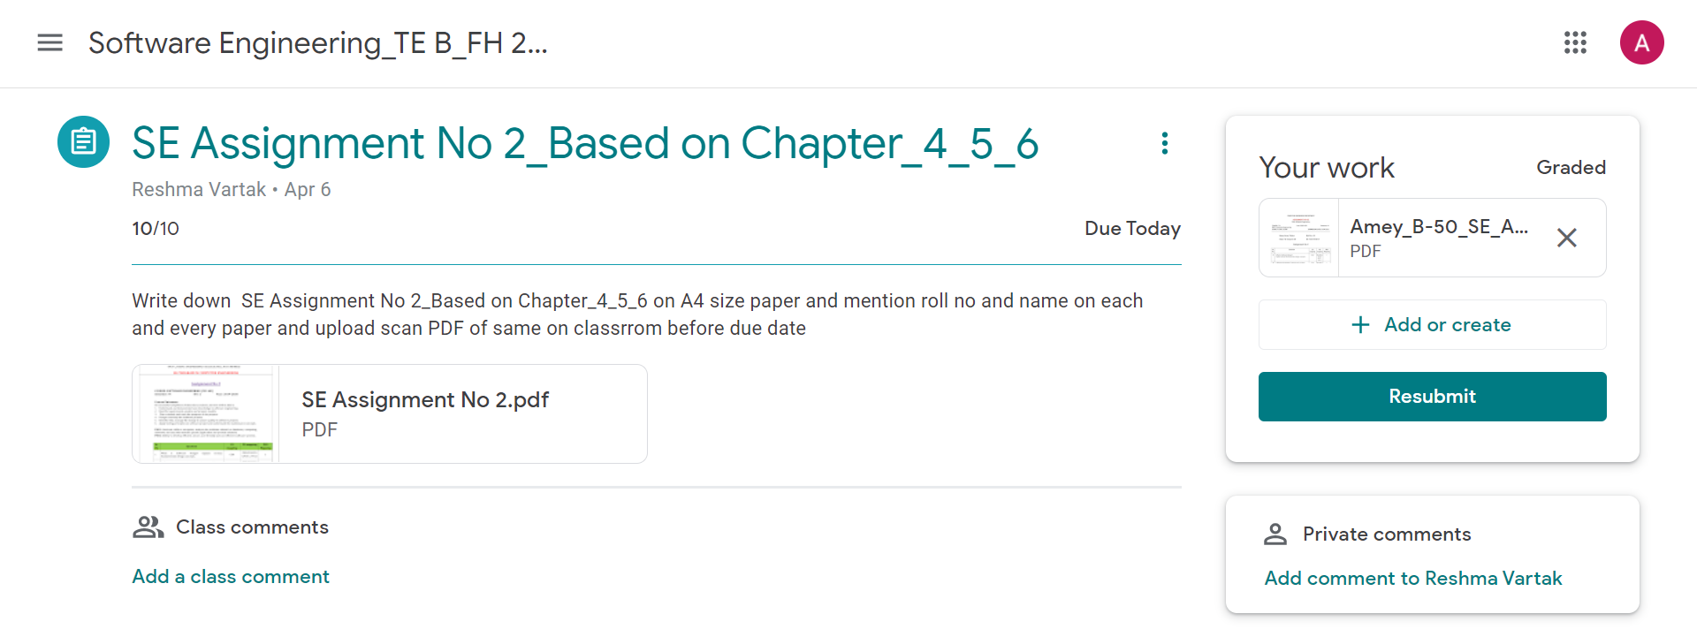
Software Engineering Assignment 3
Marks: (9/10)
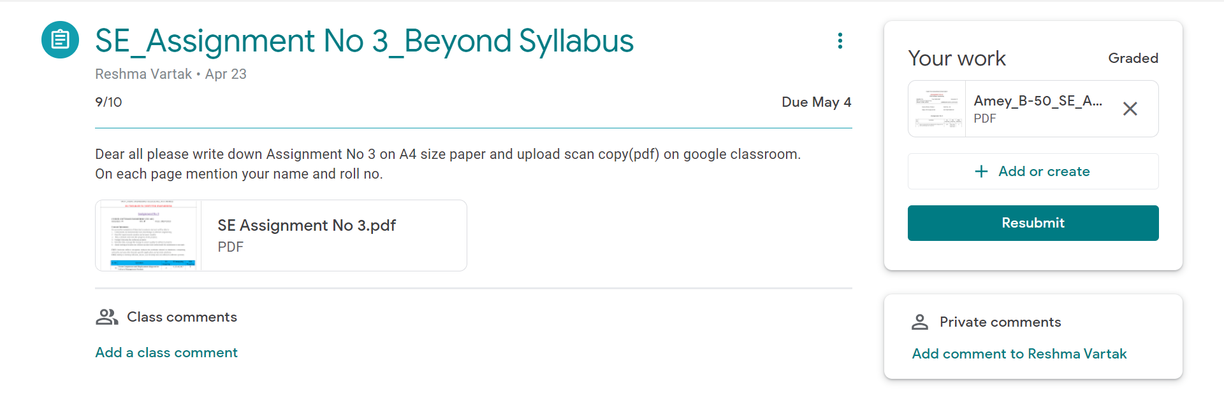

Quizzes

Software Engineering Quiz 1
Marks: (10/10)
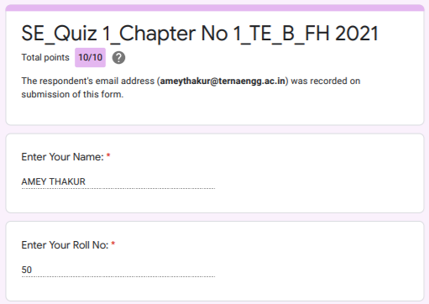
Software Engineering Quiz 2
Marks: (10/10)
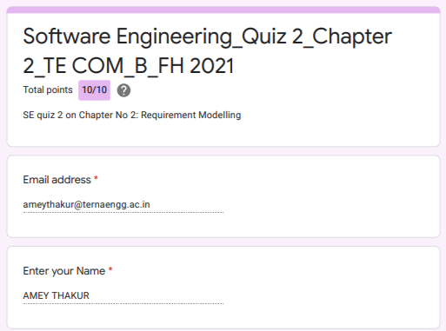
Software Engineering Quiz 3
Marks: (10/10)
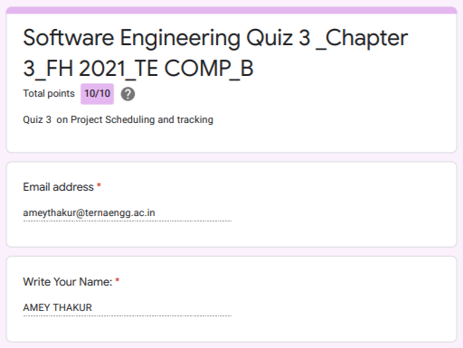
Software Engineering Quiz 4
Marks: (10/10)
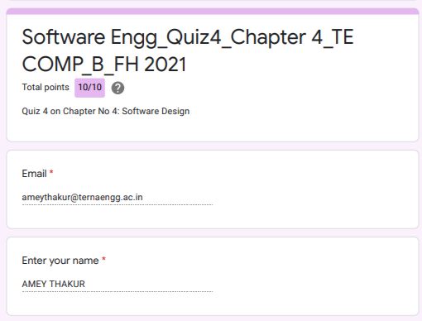
Software Engineering Quiz 5
Marks: (10/10)
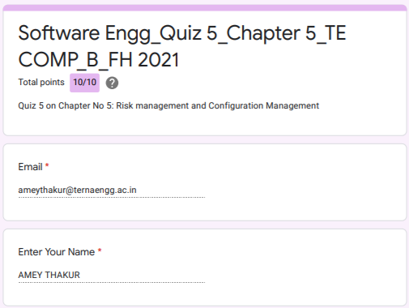
Software Engineering Quiz 6
Marks: (10/10)
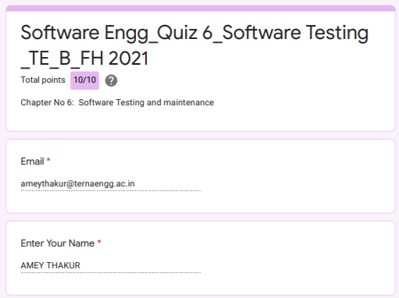
IAT

Software Engineering IAT 1
Marks: (19/20)
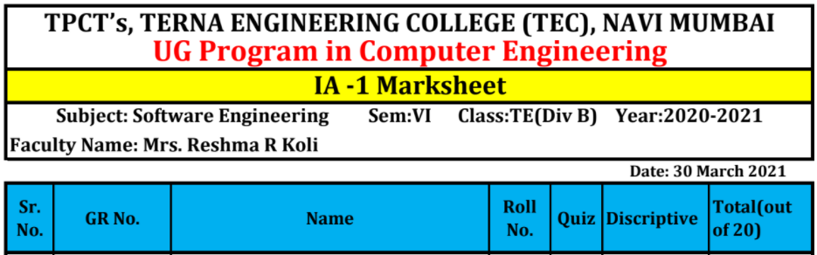

IAT 1 Descriptive Answer Sheet
(First page attached)
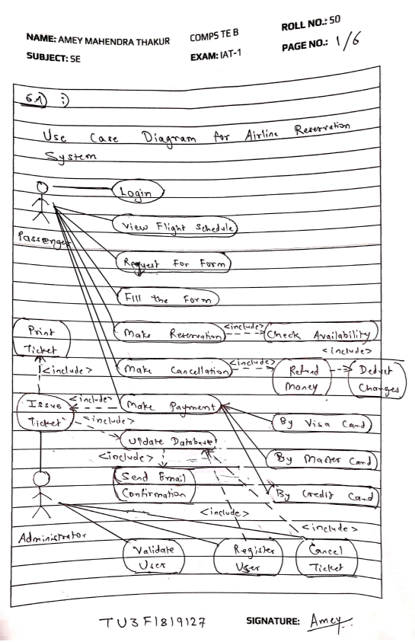
Software Engineering IAT 2
Marks: Not Received

IAT 2 Descriptive Answer Sheet
(First page attached)
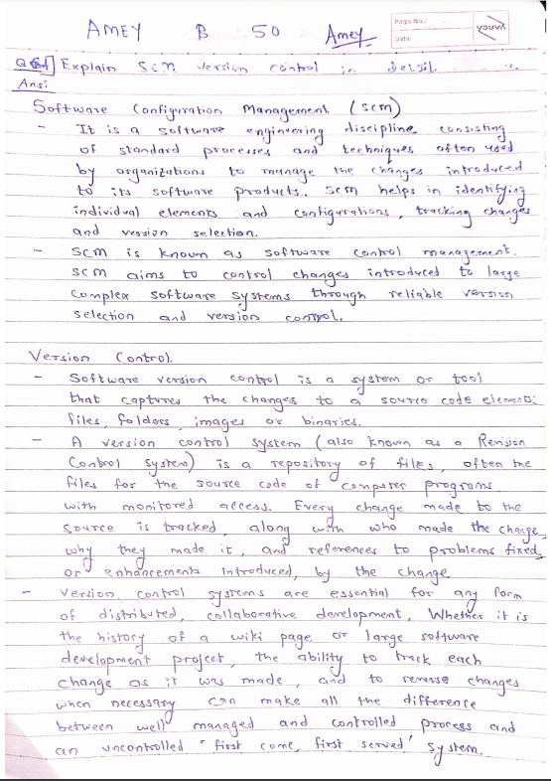
Exit Survey

Software Engineering Course Exit survey
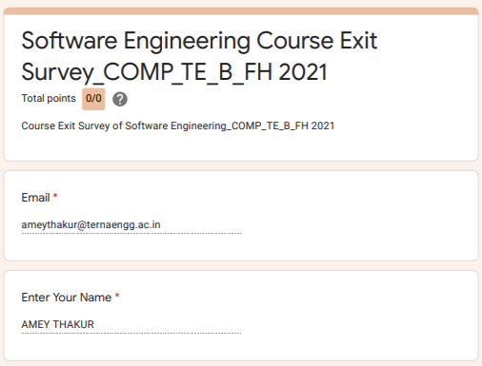
Software Engineering Laboratory Exit Survey
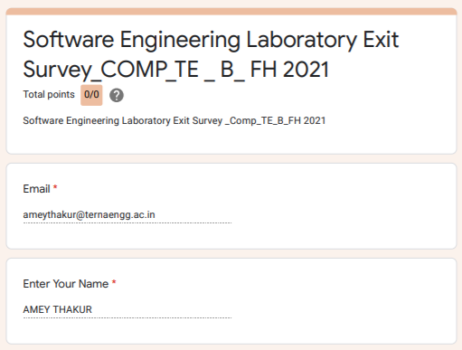
Google Classroom Submission Report
